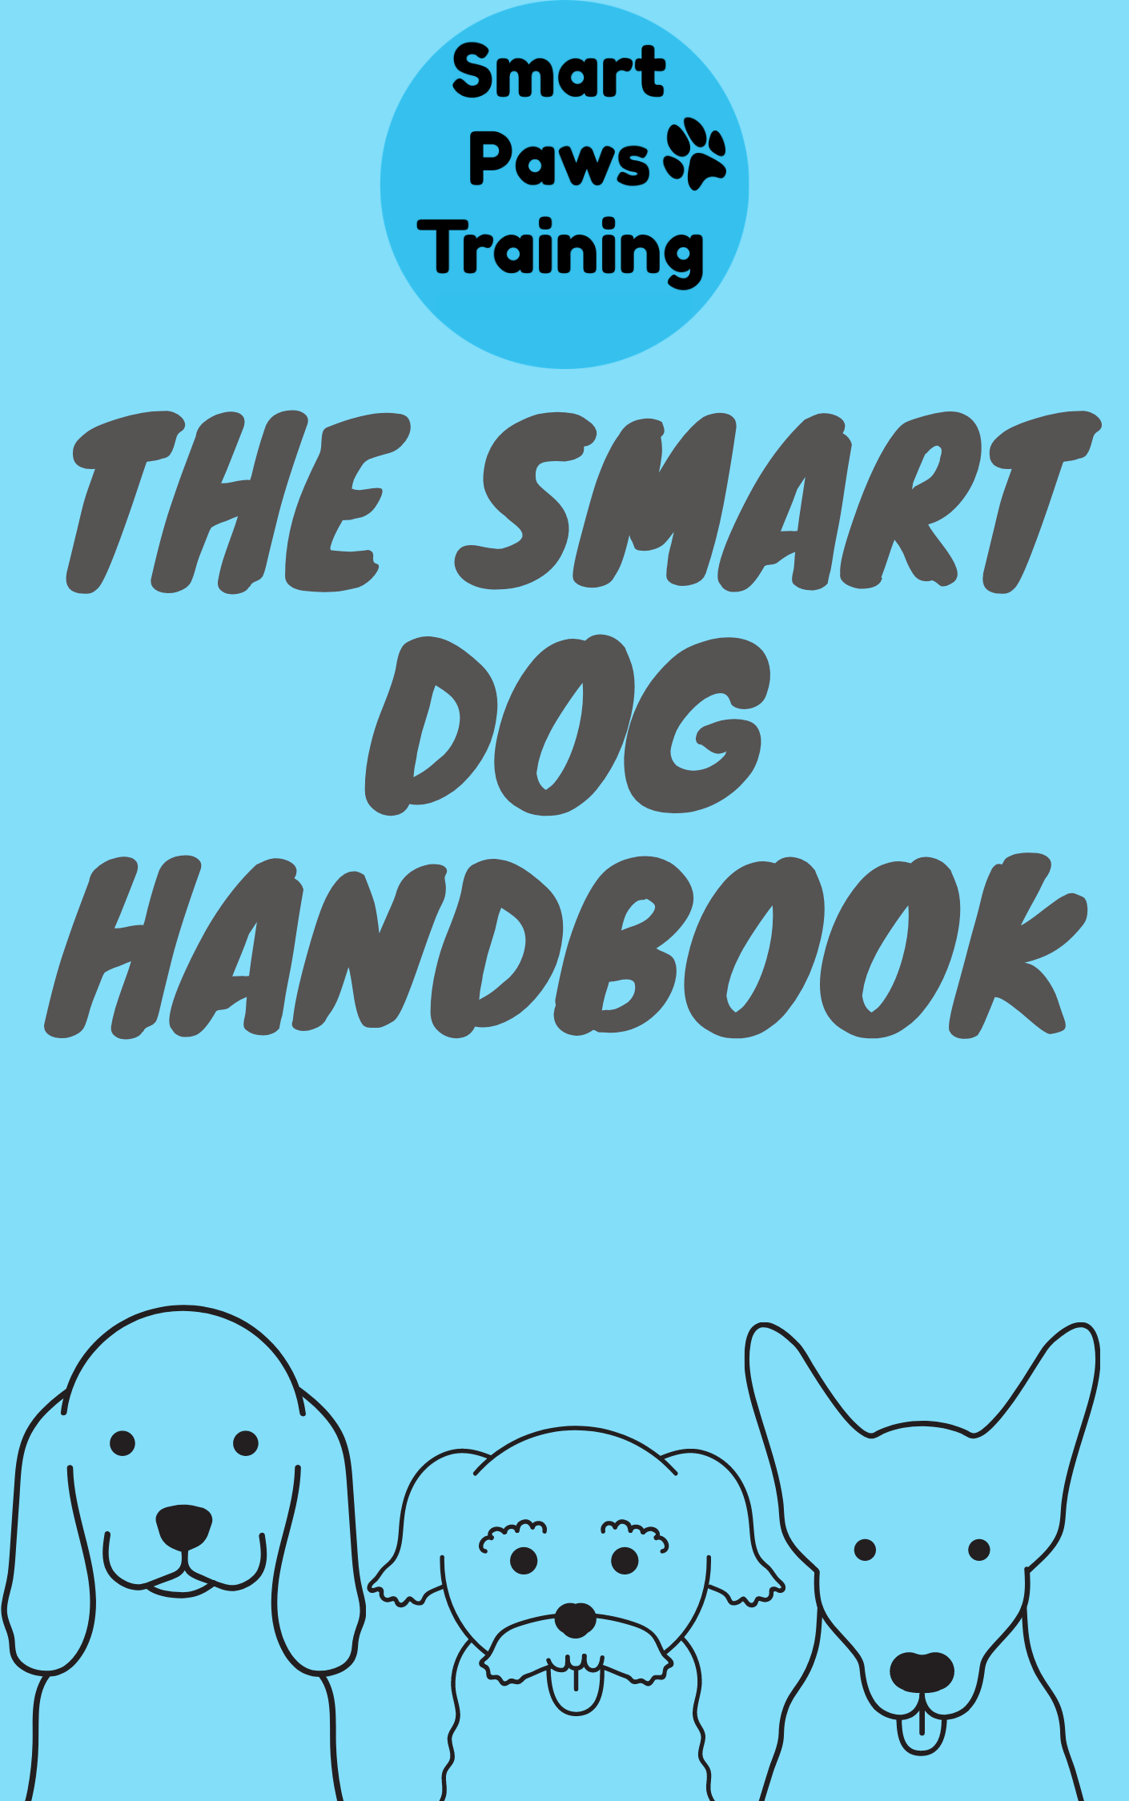

This guide is designed to help you through owning a dog with helpful hints and advice along the way

Written by Jessica Nunn
Copyright 2020 by Jessica Nunn
All rights Reserved. No part of this publication may be reproduced, distributed or transmitted in any form or by an means, including photography, recording or other electronic or mechanical methods, without the prior written permission of the author, except in the case of brief quotations embodied in critical reviews and certain other non-commercial uses permitted by copyright law.

Table of Contents
Socialisation 6
What is socialisation? 6
Communication 8
The Traffic Light System 8
Hyperarousal 13
Signs of hyperarousal 14
How do I ease hyperarousal in my dog? 14
Provide Mental/ Physical Stimulation 14
Avoid Over Excitement 14
Identify the Triggers 15
Desensitize to the Triggers 15
How Dogs Learn 15
Why do you care? 16
Training 16
What kind of training? 17
What is positive reinforcement? 17
Timing 18
Reward Marker 18
Types of Positive Reinforcement 19
Training and Distractions 20
Watch This! 20
Kids and dogs 21
Interactive game for Puppies and Kids 23
Interactive games for kids and pets 24
Children Ages 6 Months to 2 Years 24
Children Ages 2 to 8 Years 25
Children Ages 9 to 13 years 26
Jumping 27
Why do dogs jump? 27
Why shouldn't I punish Spot for jumping? 28
What should I do instead? 28
So, what methods do we suggest? 29
Become a Tree: 29
Reward Four on the Floor: 29
Teach Spot an Alternative Behaviour: 30
Practise Approaches from Humans: 30
Can my dog still jump up for a cuddle? 31
Destruction 32
Why does Spot destroy things? 32
Digging 36
Why does Spot dig? 36
So what can I do to stop Spot’s digging? 37
Other ideas to help: 39
Why Punishment Is Rarely Effective? 40
Barking 41
• Territorial/Protection 42
Management ideas for Territorial/Protection: 42
• Boredom 42
Management ideas for Boredom 43
Management ideas for Attention Seeking 44
Management ideas to prevent anxiety 44
Management ideas for Playtime Enthusiasm 45
Management ideas for Health Problems 45
Toxic Plants and Food 48
Nail clipping 49

Socialisation

What is socialisation?
Socialisation is creating purposeful, positive experiences for your dog, to prepare them for life in the human world. Ensuring our dogs are socialised correctly will have a direct and long-lasting impact on their behavioural wellness as an adult. Under-socialised dogs will almost always develop some kind of behavioural problem, like poor impulse control, resource guarding, anxiety, or even aggression.
Socialisation has many categories:
- Handling
- Animals
- People
- Locations/Experiences
- Surfaces
- Noises
We need to ensure our dogs are exposed to call of these categories.
With any experience always remember:
- Socialisation is Not the Same Thing As Exposure- Socialisation does not just mean exposing your dog to lots of things; you must ensure they are having a positive experience.
- Let Your Puppy Go At Their Own Pace- Forcing your puppy into situations before they are ready will negatively impact their experiences. Let your puppy explore the world at their own pace; you can encourage them and reward them, but don’t rush them.
- If In Doubt, Add Some Space- Your puppy doesn’t have to be right in the middle of something to have a positive socialisation experience. If you’re ever worried that a situation may be too much for your puppy, move further away and give them a chance to acclimatise.

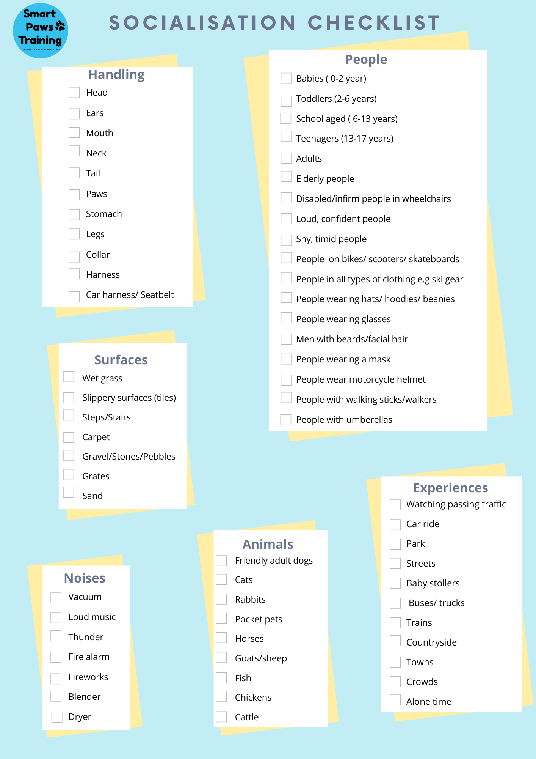

Communication
Communication is very important and understanding what our dog is telling us is important in building a trust and bond with them. Humans are a very verbal species, we mainly use words to communicate, although we still do read a lot of body language when talking to someone.
Knowing dog body language will allow you to better understand your dog and lookout for their best interests.
Through understanding your pet’s body language:
- You’ll be able to understand your dog better
- You will be able to set an appropriate pace for socialisation
- You will be able to tell whether your dog is genuinely enjoying interactions or whether they are just tolerating the situation

“Good communication is the first step in building a strong relationship with your pet.”

To help us with this we use the traffic light system:
This method allows us to establish which emotional state our pet is in during a situation or experience. We group types of body language to make it easier to interpret what our dog is saying to us.

The Traffic Light System
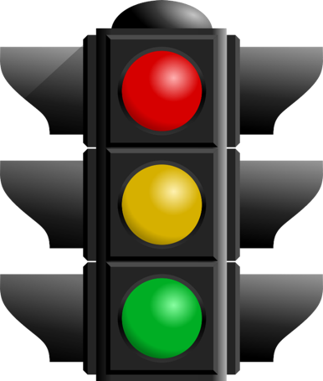
Green Zone: The dog is relaxed and happy. Keep it up – your puppy is having fun, and is able to think and learn!
Orange Zone: The dog is unsure, uncomfortable or conflicted. This is the state most people do not recognise, and the most important to learn about. Your puppy may need a little time or space to themself… .you should slow this interaction down.
Red Zone: The dog is highly aroused or fearful. He can no longer learn, think clearly, or listen to cues. ‘Survival mode’ is activated. You should immediately STOP the interaction and remove your dog from the situation.

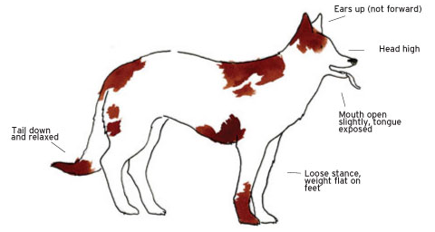
GREEN ZONE –
Relaxed
RELAXED AND HAPPY

Soft eye expression
Ears relaxed and forward
Tongue lolling
Relaxed, loose body movements
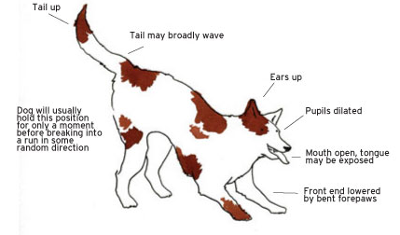
Bouncy gait when running
Loose tail wag – not too high or too low
Head held high
Playbow
Turning over, inviting belly rub
Wiggling backside.
Playful- Play bow invitation

ORANGE ZONE –
UNCOMFORTABLE OR UNSURE
If your dog is uncomfortable or unsure, they will show more than once of these signs
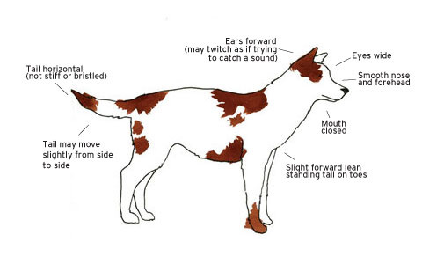
FACE
Alert and assessing surroundings
Pinning the ears back
Looking away
Whale eye
Wrinkled brow
Large pupils
BODY
Shying away
Leaning backwards
Moving very slowly
Trembling
Body hunched
Leaving the room
Jumping up
Pawing at a person
Humping
Not wanting to eat
Hackles raised
Sitting down (to avoid interactions with other dogs)
Exposing the belly

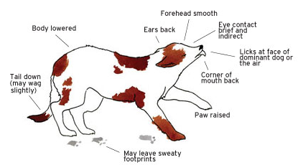
MOUTH
Fearful and worried
Closed mouth
Licking of lips
Yawning
Licking a person’s face
Panting
Lifting a lip
Showing teeth
‘Smiling’
Growling
Snapping
Barking
Stressed and Distressed
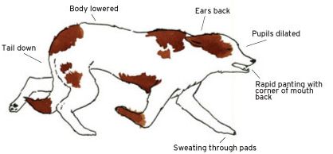
TAIL
Fast tail wag
Tail low
Tail held high and stiff

RED ZONE-
CAN NO LONGER THINK, LEARN OR LISTEN
If one strategy isn’t available, or doesn’t work, the puppy may be forced into an alternative.
Flight behaviours are all about avoiding something.
Moving away
Struggling to escape from restraint
Running away
Moving very slowly
Hiding or attempting to hide

Fight behaviours- To increase distance and make something go away.
Lip curls Barking
Growl Biting
Snarls Snapping
Lunging

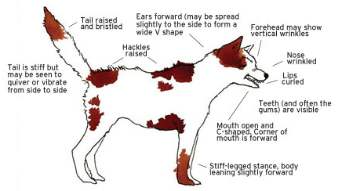
Fearful Options of Flight or Fight
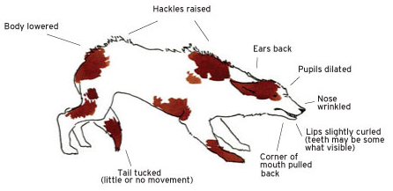

Fight Behaviours
Fiddle Behaviours- Seeking more information
Pawing at people
Licking (especially at their faces)
Jumping up
Sometimes they show conflicting body language, like approaching and then backing off, offering a play bow and then barking. Because they get really close to seek more information, if they suddenly get a fright, these dogs are also likely to snap.

Fearful and Aggressive

Freeze behaviours are all actively try to escape Freeze behaviours are all actively try to escape.
Cowering
Tense
Stiff
Immobile
Cowering
Tense
Stiff
Immobile

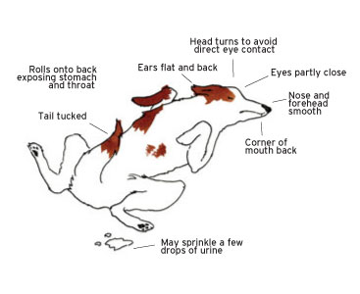

Extreme Fear - Freeze

It is really important to get to know these signs, especially the subtle ‘Orange Zone’ behaviours, as these will give you warning that your puppy or dog is not comfortable.
Recognising ‘Green Zone’ and ‘Red Zone’ signs is normally quite easy. Hopefully you will soon start to recognise some of the ‘Orange Zone’ signs too. If you are noticing that your dog is displaying these signs, then please take notice.
Remove your dog from the situation or back off a little and give the puppy some time to explore and some room to move. For example, if your puppy is yawning and looking away when a person comes up to pat him, ask that person to stop their approach and move away from the puppy, until the puppy is more comfortable. You can ask them to toss a few treats on the ground near the puppy, but don’t encourage them to hand-feed until your puppy is looking comfortable – a scared puppy might take the food but then suddenly be overwhelmed by how close the person is and bite them.
Whatever you do, do not punish ‘Orange Zone’ behaviours. If you punish a dog for growling (for example), he is less likely to growl next time. However, it doesn’t change his emotional state – in fact, it makes things worse, as now the dog is worried about whatever made him growl and the fact that you might yell at him. These dogs are more likely to bite without warning.
Some of these signs are normal behaviours – for example, it is normal for a dog to yawn when sleepy, or lick its lips after eating. It is the context that gives us a clue. If your dog was running around happily and you picked him up for a hug, the yawning or licking is more likely to be because of uncertainty. Here is news for you: most dogs don’t actually like hugs. Many of them will tolerate hugs, but there are few who enjoy it. If you are not sure, get someone to take a video of you hugging your puppy, then watch how many of the orange zone signs you see. More ‘Orange Zone’ Signs... Why? Because we cannot stress enough how important it is to recognise these signs of discomfort!
Red means STOP! Dogs in the “Red Zone” are highly aroused, often due to fear. They are unable to learn, think clearly, or listen to cues. The dog may adopt one of four strategies to get out of the situation: Fight (repulsion), flight (avoidance), freeze (inhibition), fiddle (appeasement). You should immediately stop the interaction and take steps to keep everyone safe. This is not a time for teaching.
Later, when everyone (including both you and your dog) are calm and relaxed, you can look at ways to avoid the situation, or seek the advice of a force free veterinarian or trainer to teach alternative approaches.

Hyperarousal
“ Arousal is a state of physiological alertness and readiness for action”

Highly aroused dogs are just that – they’re over-aroused by stimuli that other dogs would take in stride. It’s not a permanent state of being, it’s just shorthand for what these dogs are doing at a point in time.
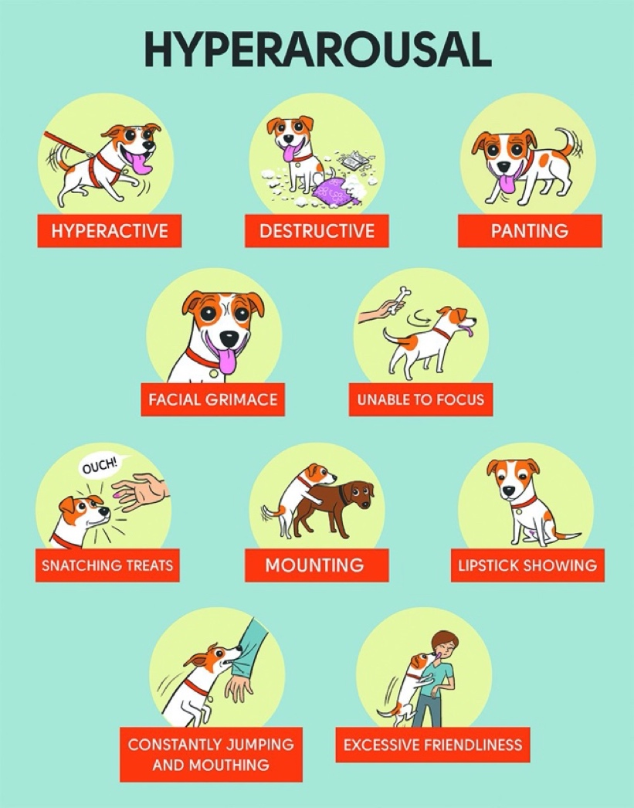
Highly aroused dogs often have a wild, almost panicked look in their eye – they’re over the top and out of control. These dogs aren’t able to think through their excitement.

Signs of hyperarousal
- Run around at top speed
- Bark incessantly
- Mouth at people’s hands or clothing, sometimes with force
- Jump at people
- Scratch at people as they jump up
- Knock children or dogs over
- Slam into people or “pop” off of them as if they were launching pads
- Grab onto their leash to play tug of war

These dogs aren’t always high energy – they might go absolutely crazy for just a few minutes, and then be exhausted.

How do I ease hyperarousal in my dog?

Provide Mental/ Physical Stimulation
The combination of lack of exercise and mental stimulation and being placed in over stimulating environments, spell disaster for these dogs. An exercised body and a stimulated mind can help lower arousal levels so there is room for learning calm behaviours. As a general rule, most dogs need at least 30-60 minutes of active exercise every day. Try to give your pet a combination of aerobic exercise and mental stimulation in the form of chasing a ball, playing fetch, exploring new trails with different scents, etc.

Avoid Over Excitement
As in everything in life, too much of a good thing can turn out being deleterious. This applies to dog owners who chronically expose their dogs to overexciting situations to a point where the dog's high arousal levels become the daily norm. Too many days in a row playing Frisbee, too many visits to the dog park or too many days at doggy day care will create a dog who is constantly overly excited. It's best to cut down the amount of exposure to these activities and replace them with other forms of physical exercise.

Identify the Triggers
You cannot work on high arousal levels until you realize exactly what stimuli or situations trigger the arousal in the first place. Identify when your dog tends to get aroused the most. Is it when you come home from work? When you grab the leash? When he sees a person or dog walk by the fence? When you prepare his meal? When you play with him? Jolt these down so you know what circumstances you need to work on. If it happens in several circumstances, you will have more work to do to encourage self-control.

Desensitize to the Triggers
Desensitization is a powerful behaviour modification technique that can help your dog learn that he can lower those arousal levels and be better under threshold. In desensitization, you are presenting the triggers which cause arousal in a less intense way. You will need to do some thinking on how to make stimuli and situations less intense. For instance, if your dog get aroused at the sight of people walking by the yard, keep your dog at a distance from the fence where he acknowledges the people, but without going into a frenzy. If your dog gets highly aroused during play, initially engage in play that is calmer and doesn't get him worked up too much. If your dog gets excited by the leash, repeatedly pick up the leash and sit down. You want to break the connection between leash and walk so his arousal levels can lower. If your dog gets too excited when you come home, act as low key as possible so you are less exciting.
TEACH “CALM” AND “SETTLE”
Adding these cues into your training will help your pet understand what you are wanting from them. To start its best to do when your pet is tired or settle down for the evening. You can approach them and gentle pat down their body using your “word “(Calm or settle) and use their reward marker. We are wanting your pet to associate the word with the action of being calm and quiet. The more you work on this the more you can use it to direct your dog to their bed, ask for a “sit” and “drop” and “settle”.

“Consistency, consistency, and consistency is the solution”

How Dogs Learn
Dog’s learn differently to humans, obvious isn’t it really, they don’t understand every word we are saying, but us learning their body language is going to be one of the best things that you have done is helping you dog live a happy and healthy life. Dogs learn that if they react in a particular way to a situation then they will be rewarded.

Why do you care?
If you understand how dogs learn, it gives you the ability to teach your dog how to fit harmoniously into your life:
- “Sit,” rather than jump on people;
- “Leave it,” rather than eat the food that just dropped on the floor;
- “Wait,” rather than dart out into traffic; and,​
- Walk politely by your side, rather than pull on leash.
It also gives you the ability to teach your dog to like — or maybe even love — things that might otherwise be scary:
- Noisy vacuum cleaners,
- Going to the vet, or
- Getting a pedicure.​
And, it can help you understand why certain things tip off the dog to be scared:
- ​You picking up your keys and briefcase tips the dog off to your leaving him alone all day,
- Getting into the car tips the dog off that he's going to the vet, and
- Rain tips the dog off that loud thunder is coming soon.

Training
The principle behind teaching your puppy is Thorndike’s Law of Effect which basically says:
If a puppy does something and it makes them feel good, they are more likely to do it again next time.
If a puppy does something and it makes them feel bad, they are less likely to do it again next time.

What kind of training?
There are two main types of dog training that can be used:
- ‘Dominance’ method dating from around the 1950s used aversive training techniques such as “alpha rolls”. Staring the dog down or other confrontational methods and punishment which can cause fear, pain and distress to dogs.
- Phrases such as “show the dog whose boss”, ‘push them lower down the pecking order’ were often associated. Dogs that didn’t do what we told them to were labelled ‘stubborn’ or ‘willful’. These methods generally do not address the underlying cause of the unwanted behaviour which is why they are often unsuccessful.
- Positive reward-based training. Dog training has evolved, and we now have more science about the best ways to train puppies. The good news is that dogs are not trying to dominate us- they never were.
Puppies live in the moment. They jump up because that’s how they greet, they pee on rugs because they are soft and absorbent, they run through the door before you because they are excited to see what is outside, and if they growl when you approach their food bowl, they are most likely worried you will take their dinner.
They are not being dominant or trying to take over the world. All these things are just natural to puppies. But they are not necessarily appropriate behaviors for living with humans. So, we use ‘Dogmanship’- the art of learning to communicate with the dog, to teach the puppy what we would like him to do and take responsibility for the training process ourselves. We are wanting to build a relationship with our dog on trust and strengthen the bonds between human and dog. Dog’s that misbehave have actually not been adequately trained for the situation.

What is positive reinforcement?
Positive reinforcement training focuses on teaching the dog what you DO want him to do in any given situation, instead of punishing him for doing anything and everything else. For example, giving the dog food reinforcement for walking at your side, or playing a game of tug if he comes when he is called. With this method, your dog comes to view you as the source of all Good Things for Dogs. He will trust you, and because you have shown him that it is in his best interest to do things for you, he will be keen to learn and train with you.
Fortunately, there is no longer any question that reward based training is a better method. Both methods can be effective and get results surprisingly quickly, but using positive reinforcement is more ethical and humane and does not have the same damaging side effects.

Timing
This is REALLY important when training a dog, because feedback about the puppy’s behaviour needs to be instantaneous – within half a second of the behaviour occurring. If you take much longer than this, the puppy may not necessarily be able to link the behaviour and the consequence. So, when you train your dog, you are reinforcing or punishing what the puppy is actually doing at the time. This means that if you want to reinforce a dog for going to the toilet in the right place, you need to be there with the dog when she goes to the toilet. If you wait at the door and reinforce her when she comes back inside, you are reinforcing her for coming back inside. Because it is so important to get the timing right, we are going to be using a ‘reward marker’.

Reward Marker
A marker signal is a way of communicating with an animal to help training go as smoothly and efficiently as possible. It is a sound or visual signal that says to your dog “You have done something correctly, and earnt yourself a reward!”
The “Click” sounds is a tool we will use to start each new behaviour. “Click” will turn grey areas into black and white for your dog. Your dog will learn that “Click” predicts a food reward. The clicker is a sharp, clear marker if used correctly and works really well.
To get started 3-5 times a day hold three to 5 pieces of food in your hand.
- “Click” and immediately give the food to your dog. Your dog can be doing any neutral, acceptable, good behaviour.
- Do not “Click” and treat if your dog is doing something unacceptable like barking, jumping or mouthing at your hand, remember you get what you pay for.
- “Click” followed by a treat should occur at random time intervals.
- You and your dog should do something different each time for variety. Just wait for your dog to offer a different acceptable behaviour.
- At this stage you are not training your dog to do anything you are simply building power value to the “Click”.
- You will find you will have your dog’s complete attention after only a few repetitions.
- Try not to “Click” at any other time unless it predicts a treat as this needs to stay a very special sound to your dog.
- Now you can use this in your training of new behaviours or even randomly for well-known ones.
- Save some of your dog’s daily rations for clicker exercises.
- Timing is very important so now you can request something like a sit and as his bottom hits the ground “Click”. This is marking the correct response and a treat must then follow.
“Click” means you end your expectation of the behaviour as well so it ends what is being done. Therefore add duration slowly before marking with yes to get length to an exercise.
Think of YES as giving a quick non emotional tick
or
OK to a behaviour at the correct moment that it occurs

Types of Positive Reinforcement
There are many kinds of things we can use to reinforce the behaviour we want.
Food tends to be the best option, because it’s a primary reinforcer (all dogs inherently like food). It’s also easy to carry around with you and can be divided into tiny portions, so you can train for longer. And after all, you are going to feed your dog anyway, so you may as well use the opportunity to teach your dog at the same time. When you train at home, you can just use your puppy’s normal dry kibble, but there are more distractions when you are out and about. From the graph it shows the more distraction the higher the food reward should be to keep your puppy’s focus.

Training and Distractions
One of the big reasons that so many dog owners struggle to improve their dog’s reliability with following cues around distractions is that they never give their dog a chance to be SUCCESSFUL around distractions.
Practising your training with no distractions is important for when you’re first teaching a new behaviour, but if you’re only training at home your dog won’t get to practise with distractions at all. If you go straight from a no distraction environment to a super busy environment, your dog is likely to struggle and fail more than they succeed. Failing over and over again won’t improve your dog’s reliability around distractions either.
Instead, try adding some steps in between the two extremes, so that your dog has the opportunity to successfully respond to their cues around distractions. For example, if your dog will listen to their name in the house, but not at the park, try practising in your back yard. If your dog can walk nicely on leash in your backyard, but not once you step out the gate onto the street, try practising in your yard with the gate open. As your dog's reliability improves, you can gradually increase the difficulty of the distractions, always ensuring your dog is able to succeed.

Watch This!
This video- Distractions- give you an idea on how your dog learns and why “the treat ladder” is so important when training and how your dog deal with distractions.

Kids and dogs
Here are a few pointers to set your family up for success in your home.
1. First and foremost, the most basic rule.
All kids should always be under direct supervision while around any dog.
It doesn’t matter whether the dog has ‘always been fine with kids’, or the kids are ‘always gentle’. It just takes one occasion where a dog isn’t feeling well or a child gets over-exuberant to cause an aggressive encounter.
What does direct supervision mean? You are present in the same area and closely observing the body language of the dog, and the arousal level of both the dogs and kids. Don’t hesitate to call for a timeout if things are getting a bit wild and woolly, even if the kids or dogs are not your own. In these situations, it is much better to be safe than sorry.
- Barriers and baby-gates are your friends. You can’t always be directly supervising everyone in your household. Use baby gates, play pens, crates or other barriers to ensure that kids and dogs can be separated while you’re not watching.
- Have a crate (or another designated area)that is a kid-free zone. Being around kids can be stressful for anyone - I guarantee that every parent has at some point wanted to crawl into a safe, kid-free space! So, make one for your puppy. Whenever the puppy is in this area, he is not to be disturbed. Children are not allowed to enter this area to play, even when the puppy is not there. There should always be an ‘escape route’ available, for the dog to access a kid-free space.
- Teach your children how to read dog body language. Remember that empathy is still a developing skill, especially in younger kids, so you’ll need to reinforce it often. For example: “See how Spot is moving away from you? That means he has had enough patting for now. Let’s go and play something else”. Or “Fluffy’s ears are back and her tail is down. She looks worried. We should give her some space”. If your dog growls at your children, stop the interaction, thank the dog for using such clear body language, and then review what was missed that put the dog in that position.

- Teach your kids the times that your dogs need space and must not be approached. This includes when dogs are sleeping, eating, resting, chewing on a favourite toy, hiding, feeling unwell, or looking uncomfortable (orange and red zone body language). Encourage your puppy to go to his kid-free zone at these times, so he can learn the best place to be unmolested.
- Anytime children want to interact with the puppy, teach them to call the puppy to them, rather than the children approaching the pup. Here is the rule that some might find unexpected: if the puppy chooses not to come when children call, that is OK. Any interaction that is forced is more likely to end in a bite. If the puppy isn’t interested in playing with kids at that point, his choice should be respected.
- Children must always treat the dog with respect. This means no riding, dressing up, lying on, or using as a pillow, no “roughing them up” with hands around the face, no pulling tails, ears or fur. Even if your puppy or dog “lets the kids do anything!”, he is unlikely to be enjoying these things. Watch for ‘green zone’ body language to be sure. Because children learn by imitation, this means that all adults must also treat the dog with respect. Using positive reinforcement to teach your dog what to do sets a great example.
- It takes practice for a puppy to be calm around children. Once your puppy is familiar with settling on a mat, then you can take him on a lead, with his mat and sit next to him to watch kids play. If you don’t have your own kids, you could set up a picnic rug near a playground, or at a sports field on a Saturday. Use high value, high frequency reinforcement as kids can be pretty fun and distracting. Remember to start with short (1-3 minute) sessions initially.
- Young children shouldn’t be allowed to pick up the puppy. It is difficult for a child to manage to support a puppy correctly, which makes it uncomfortable for the puppy. Show them how to interact with the puppy with all four paws on the ground.
- Children should be taught to tell an adult if the puppy or dog is doing something it shouldn’t. If kids start telling the dog off, or trying to push them away from their toys, the dog may take offence. An adult can step in and calmly redirect the dog to a more appropriate behaviour.

Safe Ways for Kids to Play With Dogs
Kids and dogs can be great friends and companions. Studies have shown that having a companion animal can increase empathy and self-esteem in children. Miscommunications between kids and dogs are common. When we have a dog we need to make sure that our puppies are not man handled and they have a bed or crate area. This area is only for you pet. When they are in or on this area we are not allowed to interact with your pet. Our dogs need boundaries and to be able to have somewhere to relax- honestly we all even have this area.
Watch This!
The video Stop the 77 - Campaign Aims to Dog Bites & Keep Kids Safe

Interactive game for Puppies and Kids
Dogs are stimulated by movement and noise and children are known for their movement and noise! Still, it is possible to work toward and achieve positive and comfortable relationships between dogs and kids.
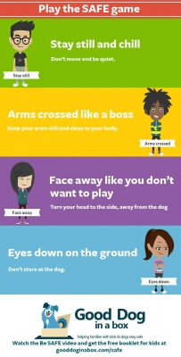
"Be a Tree"Game
One of the most valuable skills that children can learn is to stand still and "Be a Tree" if a dog comes near them, or if a dog is bothering them, jumping up, biting or becoming too frisky.
1. Stop- Stay still and chill
2. Fold in your branches (hands folded in front)- Arms crossed like a boss.
3. Watch your roots grow (look at your feet)- Eyes down to the ground
Count your breaths in your head until help comes or the dog goes away.
"Trees" are boring to dogs. A dog will just sniff at a child/tree and then go away. No matter what the dog does, it is important for the child to stand still, avoid eye contact (by looking down at his/her feet), and stay quiet.
It is not enough to tell children about being a tree. Kids need to practice the behaviour in a low-stress environment in order to have the best chance of recalling the behaviour in real-life conditions.
A fun way to emphasise the safety details of the "Be a Tree" is to engage in role-playing games where players take turns pretending to be a dog. While one player is the dog, other players practice being trees when the dog comes near them. It is also possible to practice "Be a Tree" steps with a stuffed dog (although if you have a puppy or a small dog, you may be able to play with the real dog).
In the game, everyone moves around. When the dog (person in the dog role, stuffed dog, or small real dog) comes up, players assume the tree position. The adult in charge of the game should say the dog's name before the dog gets to a child and give the dog a treat . In this way, the dog is rewarded for keeping all feet on the ground when the dog is around the kids. A dog will soon learn that when the kids act like trees, no one will move or play anymore.
With a larger dog or a very frisky dog, start the game with the dog on a leash. Approach one of the children in the game. Have that child "be a tree." Say the dog's name, ask the dog to sit, and give a treat. Repeat these steps until the dog looks at you and sits automatically when he sees a kid being a tree.
Remember to keep things calm with the kids during the practice game. It is not a good idea for children to run around and get a dog all riled up.
Watch this!
BE SAFE- Dog Bite Prevention Video for Kids | Good Dog In A Box
Great to watch with the kids!

Interactive games for kids and pets
Your kids are your pride and joy, and your dog is your best furry friend, so you want to make sure that both are safe and happy when it comes to playtime. Just like with any other activity, kids need to be taught how to safely interact with the dog so that everyone is safe and has a good time. Playtime with the dog needs to be age appropriate and well supervised by an adult. Here are some tips for playtime with your pup, broken down by your children’s ages.

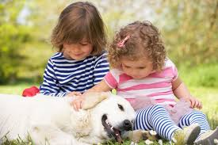
Children Ages 6 Months to 2 Years
Fostering a good and gentle relationship between your child and your dog starts early. Your baby/toddler needs very close supervision when interacting with the family dog. Here are a few activities you can try to build their relationship.
- Play hide and seek with your dog. Hide with your child and call your dog to come find you.
- Play peek-a-boo with your dog. Conceal your dog behind a cloth and pull it aside to make your dog reappear to your child.
- Teach your child how to properly pet the family dog. Call the dog over to your child, carefully observing the dog’s body language to make sure he or she is comfortable, and teach your child how to gently pet the dog’s body. (Note, many dogs do not like being pet on the head, so avoid this.)

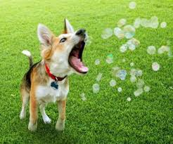
Children Ages 2 to 8 Years
- Let your child throw the ball or toy for your dog to fetch. (Smaller children can stand on a stool to be taller or behind a baby gate to avoid getting jumped on.)
- Let your child play hide and seek with your dog. You stay with the dog while your child hides, armed with a few treats. Let your child call the dog and give the reward when the dog finds him or her.
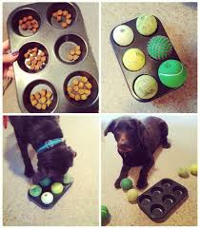
- Give your child bubbles to blow, and let your dog pop them.
- If you have a water-loving pup, let your child spray the hose (not directly at the dog, but near him or her), and let your dog chase the water stream.
- Play the Muffin Tin Game. Have your child hide treats in the cups of a muffin tin. Cover the holes with tennis balls or dog toys. Have your dog wait. Then let your child place the pan on the floor and say “Find it!”
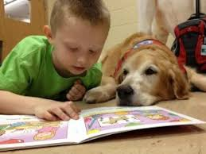
- Fill a Kong with goodies. Show your dog. Have your child hide the Kong somewhere where the dog can fairly easily find it. Have the child return and tell the dog “Find it!” As your dog gets better at sniffing out the treat, have your child make it more challenging.
- Have your child read a book to your dog. It is a non-judgemental setting, the children's focus improves, their literacy skills increase and their confidence soars.
- Brain games: encourage your dog and child to play games that make the dog think, like placing a treat under an overturned laundry basket. See how long it takes the dog to figure out how to get the treat out.

Children Ages 9 to 13 years
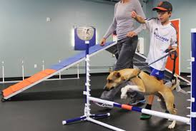
- Have your child play Frisbee and fetch with the family dog.
- Bring your kids to a dog training class to learn how to work with your dog at home.
- Let your children research new tricks for your dog and teach them using the same steps from training class. New tricks could be roll over, sit, stay, beg, shake or speak.
- Have your child compete in more complicated races, like running through agility type exercises with your dog.
- Have your children research how to make homemade toys and games online and make them for the dog, such as braided tug toys out of old T-shirts or snuffle mats out of old fleece blanket scraps.

Jumping
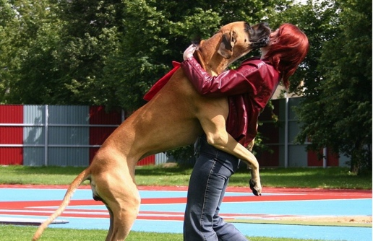
Jumping up on people is a very common, natural doggy behaviour which most people find difficult to prevent. It is not a pleasure to own a dog that jumps on your family and visitors. Quite apart from the nuisance factor of having muddy footprints on clothing, your dog (let's call him Spot) can cause injury to people by knocking them off-balance and sometimes tearing skin with his doggy claws.

Why do dogs jump?
To find a way of managing this behaviour you must first understand why jumping is a natural behaviour for Spot. To do this you need to look back to when Spot lived in a social group of wolves - before he was domesticated by us.
Jumping is generally thought to be a behaviour left over from Spot ‘s wolf ancestors. Wolf pups licked their mother's mouth when she returned from hunting and this caused a physiological response in the mother to regurgitate some of the food she was digesting. The puppies then ate this to supplement their milk diet, and to aid in their introduction to solid food.
This behaviour soon turned into an appeasement gesture toward their mother and other group members. Puppies licked at mouths and faces to indicate that they were babies and therefore of no threat to older bigger wolves.
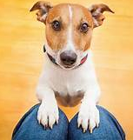
Similarly, in our world Spot learns as a puppy to reach up and lick his mother's face for attention and to appease her when she is angry with him. This behaviour then turns into jumping up as he transfers his efforts to humans, who are of course generally taller than his mother.
When Spot jumps up at humans they are seduced by his cuteness and unintentionally reinforce the behaviour by giving him the attention he craves. They "gooh" and "gah" over him, chat to him ("Aren't you beautiful!") and often reach down to pat him whilst he paddles his forelegs against their shins. Even more often their response is to lift
Spot up to their level so they can cuddle him more closely.
All of the above responses are seen by Spot as rewards for jumping, so he learns pretty quickly that jumping up gains attention and (in his view) appeases the human members of his social group, so he thinks it must be a pretty good thing to do. Sometimes this can even result in Spot feeling that his status in the group has improved, because he is gaining attention on his terms. This can eventually cause leadership problems.
Although humans tend to tolerate (and unwittingly encourage) this behaviour whilst Spot is a puppy, they then complain when it becomes a problem as Spot grows larger and is still jumping up when he is maybe 65 cm tall and weighs 40 kg!

Why shouldn't I punish Spot for jumping?
Punishments such as stepping on Spot ‘s toes, yelling at him to get down, and smacking him, although intended to dissuade him, usually cause him to jump more! He sees that you are frustrated with him and tries even harder to appease you by jumping more in attempts to get closer to your face to lick.
Also, because Spot is essentially a social animal, in his view any attention is better than none. Your physical punishment may be seen by him to be better than no attention whatsoever. Punishment can also cause other problems with Spot. For example, smacking Spot when he jumps may result in him beginning to fear a hand coming toward him, as he may think it intends to punish him. He may then end up displaying aggressive behaviour toward humans in order to protect himself from what he sees as a threat.
Young children in particular can become unintended victims of this punishment. They tend to wave their hands around more than adults and Spot may decide they are threatening him, so may react in an aggressive manner toward them.

What should I do instead?
We recommend that you use simple, non-threatening methods to discourage Spot from jumping up. These methods are based on giving Spot attention on your terms, not his. You also need to set him up to succeed. By this, we mean ensuring that Spot doesn't have the chance to be rewarded for jumping, as every time he is rewarded – either intentionally or unintentionally – the chance of him jumping again increases.
So, to begin with it is a good idea to have Spot on lead when expecting visitors in the early stages of "no-jump" training. This is not so that you can jerk him away from the visitors – an act that would probably give Spot bad feelings toward visitors! This is to allow you to control his access to the visitors, so he cannot go racing toward them to jump all over them.
You can actually use the visitors to teach Spot that jumping is not a required behaviour by having treats ready for the visitors to give to Spot when he is behaving well. (See "Reward Four on the Floor" and "Practise Approaches from Humans" methods below.)
Everyone in your family must also understand what methods you are using and why they need to follow the rules about not rewarding Spot’s jumping. It is confusing for Spot if one family member allows jumping when others don't. A commitment must be made by the whole family so that you can succeed in having a "no-jump" dog.
If Spot is a small puppy and people want to say hello to him, we suggest that they kneel down to Spot ‘s level. This way young Spot may not feel he needs to jump. If everyone does this with Spot from the beginning, then Spot may not learn to jump up at all!
However chances are that Spot will already have learnt that jumping is rewarding - you now have to stop a behaviour that has already become a habit.

So, what methods do we suggest?
We have found the following methods to have a high success rate with jumping dogs, particularly if they are all put into practice:
- Become a Tree
- Reward four on the floor
- Teach Spot an alternative behaviour
- Practise approaches from humans
Let's have a look at these methods in more detail.

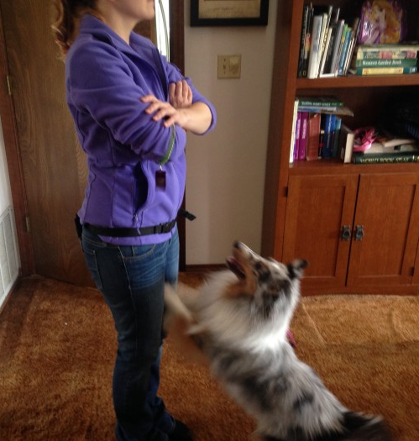
Become a Tree:
One of the easiest ways to let Spot know that jumping is not a behaviour you want, is to ignore him and become a tree (see “Interactive Games for puppies and Kids” for more info) when he jumps. Any reaction from you will be seen by Spot to be a reward and will probably cause the behaviour to increase. So, you need to learn not to react to his jumping either verbally or physically, so that he receives no reward to encourage him. You must be silent, not yelling or saying "get down", "stop that", etc. You must also refrain from pushing him away, or kneeing him in the chest because Spot will view this as attention.
You need to ignore Spot when he jumps, and even give him the "cold shoulder" by folding your arms and turning away. If you do this, Spot fer will work out pretty quickly that jumping up doesn't give good results. This method works best when followed by the "Reward Four on the Floor" method.

Reward Four on the Floor:
Remember that Spot will repeat those behaviours which are most often
rewarded, so to encourage Spot to keep his four paws on the floor it makes sense to reward him when he does this!
So, if Spot jumps up at you and you ignore him, you must remember to quickly praise and reward him as soon as all four of his feet are on the ground. You should praise him and give him a couple of tasty treats, or a favourite toy to play with. If you do this consistently, Spot will soon learn that having "four on the floor" is much more rewarding than jumping up at you. You must be quick with your praise and rewards, so that Spot understands why he is being rewarded.
Better still, try to catch Spot with four on the floor before he begins to jump or even thinks about jumping. You can turn this into a game for the whole family, with a reward for the person who is jumped on least! This way, Spot doesn't get the chance to practise jumping.

Teach Spot an Alternative Behaviour:
Another good way to teach Spot not to jump, is to teach him to perform an alternative "good manners" behaviour instead. So, for instance, teach Spot to sit when you approach him, or when he approaches you. If you request a sit and reward him consistently for sitting, he will be far more likely to sit than to jump, as he will remember that sitting brings a reward.
After a while he will begin to sit automatically, as you will have reinforced this behaviour so often. If Spot is sitting, he cannot physically be jumping at the same time!

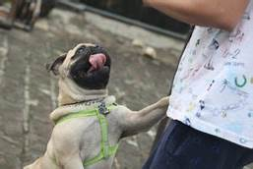
Practise Approaches from Humans:
Now that you have some ideas on how to teach Spot that jumping doesn't pay, you need to practise a lot. However, before you practise, you must teach your family and helpers what they must do to help Spot learn not to jump. So explain the rules to them before Spot is allowed to greet them.
If you have visitors who don't want to follow the rules, then we suggest that Spot be given an alternative activity away from them whilst they are visiting. Everyone who will be helping must also have treats available to give to Spot when he does the right thing.
Begin with Spot on lead, and have your helpers approach him one by one. If Spot is four on the floor, or sitting, they must reward him straight away with a pat and a treat. If he jumps they must turn away from him and only turn back when he is four on the floor again to give an instant reward.
It is a good idea if you have rewards ready as well. That way, if your helpers are not quick enough with their reward, you will be able to reward him instead. It is even a good idea to vary where the rewards come from – sometimes from you, sometimes from the person approaching – this way Spot will not think other people are always more exciting than you!
Sometimes Spot doesn't quite understand what you want. He may stay down until you reach him and then suddenly jump up. In this case you need to keep Spot reward down low, so he is not encouraged to jump. Try quickly crouching down as you get in close to him and reward him from this lower position. Progress to a more upright approach after a few low approaches – do this gradually to help Spot succeed.
Also, try using your free hand to give a pat as you offer the treat. Rubbing Spot’s chest instead of his head or neck will also encourage him to stay down. Gently throwing some treats on the ground near Spot as you approach may also help, as he will focus on the treats, not on you. This will give you time to get in close to him and the opportunity to reward him for the desired behaviour.
These approaches need to be practised in all the places you would normally take Spot, so that he learns that jumping up never pays – no matter where he is.

Can my dog still jump up for a cuddle?
Some people are happy for Spot to jump up on them occasionally, as long as he doesn't jump on other people. We suggest you teach Spot this only after he has mastered the art of not jumping.
If you want Spot to jump up to give you a cuddle, then it is best to put the "jumping up" on cue (a voice and/or body signal) and only ever reward Spot for jumping up if you have requested it first.
Your cue may be something like saying the word "Cuddle" as you pat your chest or hold your arms out to him. If Spot jumps up, reward him with a cuddle and then release him.
Only ever reward him for this if you have requested it first – never reward him for jumping up before you request it.
If he begins to jump up again without your request then it may be best if you don't allow this behaviour at all, as Spot may be confused about when he is, and isn't, allowed to jump.

Destruction
Oh no - it's happened again! You've come home to find the washing strewn across the backyard, your favourite pot plants shredded and the family's shoes bearing that "custom-made-tooth-mark" look! In the midst of this mayhem sits your dog, scraps of your best jeans hanging from his mouth and a look of extreme guilt on his face. Obviously he knows he's done the wrong thing – his ears are back, his tail between his legs – if ever there's been a guilty dog, this is it! To make it worse he jumps up at you and licks your face – such defiance!
STOP! Spot is not displaying signs of guilt or defiance – he is merely reacting to your body language, tone of voice and obvious distress. From his point of view he was having a wonderful time playing with all the exciting toys you left out for him – and even better, most of them reminded him of you because they held your scent. Suddenly you've arrived back and are displaying some abnormally aggressive behaviour which seems to be directed at him. Spot has no idea why you are angry with him, only that he needs to do his best to make you happy again – hence the grovelling, jumping and licking.

Why does Spot destroy things?
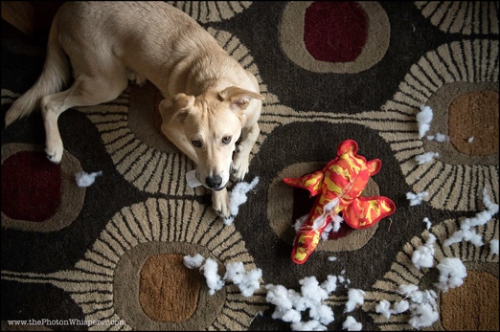
"Destructive" behaviour can be the result of:
- Lack of training
- Boredom
- Attention Seeking
- Anxiety
- Playtime Enthusiasm
- Health Problems
- Hunger/Thirst/Shelter

Let's have a look at each of the above and explore ideas for alleviating the problem.
- Lack of training
It is not fair to complain about destructive behaviour if you have not taught Spot what is, and isn't, appropriate for him to play with. Spot will not naturally know the difference between your best shoes, and the old loafer you gave him to chew on. He will not know that the flapping, whirling items on the clothesline are your clothes and are out of bounds as playthings – just as a toddler doesn't understand that grandma's doll collection is only for looking at, not for touching.
Management ideas for lack of training
- Teach! To be successful in having a non-destructive dog, we need to provide items that Spot can play with – and teach him to play with them. A plastic toy only becomes a toy in Spot’s eyes if you teach him that playing with it is rewarding.
- Make it clear that you are pleased with Spot for interacting with the items he is allowed to play with, such as chew toys and bones, etc., by praising and playing with him.
- Restrict Spot’s unsupervised access to those items which are dangerous or which he cannot interact with and supervise him whilst training that those items must not be touched.
- Provide alternatives – if Spot shows an interest in a "banned" item, entice him away to something more exciting or rewarding and praise profusely for doing the right thing.
- Clear your yard and house of items at puppy level as much as possible (time for a good spring clean!) leaving only those items which he is allowed to play with. Gradually reintroduce the "banned" items without making a fuss and encourage Spot to go and find his toys instead of the new item.
- Teach Spot the meaning of "Leave" – ask your Instructor for more information on this.
- Teach Spot to accept being confined, either outside in a pen, or inside in a crate or small room. If Spot is confined to an acceptable area when unsupervised he will not be able to gain access to items you value. Make sure you leave something to keep him occupied, along with bedding and water.

- Boredom
Boredom is the result of insufficient mental or physical stimulation. Spot can suffer from boredom if his environment is lacking in stimulation. Even a big yard can be just a large prison for him: he has all day, every day, to get to know every inch of it. Spot cannot relieve the stress of boredom by going for a walk, reading a book or visiting friends. If the environment you provide does not have enough variety or stimulation for him then he will begin to look for activities to keep himself occupied and relieve his pent-up energy.
Management ideas for Boredom
Enriching Spot’s environment with activities and items of interest will help alleviate boredom. Ideas for enrichment will be found in the “ Interactive Games for puppies and Kids” section.
- Attention Seeking
As we said earlier, Spot is generally a social animal. He enjoys company and is not overly content if left alone a lot. Spot may have discovered that playing with items you value, especially those with your scent and which you pay a lot of attention to (e.g. clothing, plants, etc,) tends to gain attention – even if it is the wrong attention! Spot soon learns that if he plays with one of these items someone will interact with him in some way.
In Spot’s opinion sometimes any attention is better than no attention. Even you yelling and chasing him around to retrieve the item is seen by Spot as being worthwhile – he has gained your attention and you have interacted with him.
Management ideas for Attention Seeking
- The main issue here is to pay more attention to Spot when he is playing with something you want him to play with and calmly remove items he is not allowed to play with, or remove him from the items and redirect his attention elsewhere.
- Try to anticipate those occasions when he is about to do something to gain your attention and divert him before he begins. If you miss this opportunity and he has already destroyed something, see this as a sign that you need to provide a more stimulating environment, or train him better.
- Ensure Spot has daily interaction with you to fulfil his social needs. If he has his mental, physical and emotional needs tended to, he will be less stressed and less inclined to want your constant attention.

- Anxiety
Do you find that Spot follows you everywhere when you are at home, possibly even trying to go to the bathroom with you? Does he complain when shut away from you?
Allowing Spot to become very dependent on you can lead to anxiety when you are away, which in turn can cause Spot to become destructive because he is anxious and upset. Even a simple change in your daily routine or household circumstances becomes a major issue for him. This can be a most frustrating problem and it is best you ask your Instructor for a referral to a qualified Veterinary Behaviourist if you feel Spot has this problem.
Management ideas to prevent anxiety
To prevent Spot from developing this problem, try the following:
- When you know you will be away from home, ensure Spot has plenty of environmental enrichment to keep him occupied.
- Prepare a meal for Spot and give this to him as you leave. Better still, use a Kong or food dispenser so that Spot is kept occupied for longer eating his meal.
- Try leaving a radio or TV on softly in the background to give the impression of company.
- Gradually get Spot used to being separated from you for an increasing length of time while you are at home. Put his bed in a convenient area where he can see you moving from room to room and install a cheap, simple toddler barrier in the doorway to stop him from following you everywhere.
- Keep arrivals and departures very matter of fact and low key - don't make too much of a fuss at either time.
- Reward Spot when he is quiet and relaxed and/or playing with appropriate items.
Playtime Enthusiasm
You may find that Spot tends to become destructive when he is playing - it is natural for dogs to want to grab, tear and chew when excited.
Management ideas for Playtime Enthusiasm
- The key here is to reward Spot for calm, quiet behaviour and show him that play will stop if he becomes destructive.
- If he will not stop, put the toy away and try again later.
- Reward him with a treat when he brings toys back to you and begin playing again before he has a chance to stop and chew or tear.
- Keep play sessions low key to prevent escalation of excitement. High intensity play sessions should only last for a short while between calmer activities.
- Request a good manners behaviour such as "sit" or "drop" before and during play sessions to refocus him.
- Teach him to settle between throws or tugs.
- Playing tug games can encourage destructive behaviour, so think carefully about whether you really want to play these games and consult your Instructor on how to avoid problems if you decide to play tug.

- Health Problems
Does Spot suffer from fleas, a skin allergy, or a dental problem? All these things can contribute to making him irritable and more likely to be destructive, particularly toward his bedding. If he has fleas or an allergy he may tend to scratch whilst on his bed, which may cause his bedding to tear and become a target for Spot’s interest. A dental problem may make Spot more inclined to want to chew to try to relieve tension and pain in his mouth.
Management ideas for Health Problems
Make sure Spot is in good health. If any of the symptoms mentioned above are present, or if you feel there is anything unusual about his state of health, make sure he has a Veterinary check-up immediately. These conditions and other health problems can contribute to behaviour problems.
- Hunger/Thirst/Shelter
Check Spot’s living conditions thoroughly. Is he well-fed? Does he have access to plenty of clean, cool water? Is he sheltered from climatic conditions – both hot and cold? His destructive behaviour may be an indication that he is uncomfortable. It is your responsibility as his primary carer to make sure he has all the necessities for a comfortable life.
Why shouldn't I physically punish Spot for destructive behaviour?
Some people promote various punishments for "demolition dogs", ranging from yelling, to hitting with rolled up newspapers, or using electronic or chemical collars.
In most cases the punishment does not deter Spot, as the reason for his destructive behaviour is not being addressed. Punishment will tend to make Spot anxious and stressed because he will associate the punishment with you, not with the act he committed prior to you arriving on the scene. Punishment can also cause Spot to display aggressive behaviour toward people – hardly conducive to a good relationship between you and him!
We believe it is far better to work out why Spot is displaying destructive behaviour and remedy the situation using the ideas given here and in the “Backyard Fun for Your Dog!” handout.
Are there other reasons why Spot destroys things?
Yes! We have listed only the most common reasons, but there are many other reasons why Spot may shred, tear, chew, etc. It is up to you to use your initiative to think about why Spot is destroying things and work out solutions which suit you both. You really need to be honest and fair when doing this – have you really taught him what is his and what is yours? Have you really provided enough environmental enrichment for him?
A demolition dog can be frustrating to live with, however if you are observant you can usually discover what makes Spot behave the way he does. Applying the appropriate management ideas will generally help, however for best results do this under the supervision of your Instructor.

Digging
Is your dog a keen landscape gardener? Does he put a back hoe to shame with the number and depth of holes he can dig? Do you doubt ever being able to have a nice garden again? Understanding the reasons behind your dog's digging behaviour will help you to manage it more effectively.
Digging is natural
You'll be happy to know that your dog (let's call him Spot) is not digging to annoy you! Digging behaviour is entirely normal and natural for a large percentage of the doggy population. It varies between breeds and individuals. Some dogs love digging holes. On the other hand, some dogs couldn't be bothered.
If Spot loves to dig then the following suggestions may help you to live more harmoniously together.

Why does Spot dig?
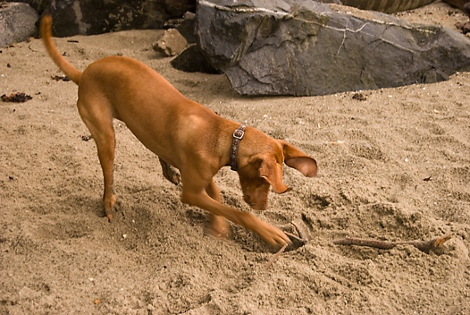
There are many possible reasons for Spot to want to dig. These can include:
- Burying items or uncovering something perceived as buried.
- Using the soil temperature to help regulate body temperature.
- Expressing anxiety or attempting to escape.
- Nesting rituals for bitches.
- Playing.
- Territorial marking.

It helps to identify which of these reasons apply in your situation. Knowing why Spot digs will help you to work on managing the behaviour. Observe Spot closely for a few days and you will probably be able to work out why he is digging. When you have done this, you'll be able to apply the most appropriate suggestion offered below.
Do not despair if you cannot work out why Spot is digging. You can still put these suggestions into practice one by one. If you try a suggestion and it doesn't help, simply progress to the next. None of the suggested actions will harm Spot and in fact most of them are a good idea to implement anyway, as they will improve Spot’d enjoyment of life!

So what can I do to stop Spot’s digging?
It may not be possible to stop Spot’s digging behaviour entirely; however the following suggestions may help to manage the behaviour:
- Burying items
Spot’s ancestors buried food and bones if there was a surplus, so they had supplies to fall back on if food became scarce. So although Spot probably has a regular food supply, his instincts may still prompt him to bury bones, especially large bones, so he can consume them later.
This behaviour may be particularly prevalent if Spot is the only dog in the family, because he has the luxury of knowing his bones will be safe. When there is more than one dog in the family the incidence of bone burying seems considerably reduced – probably because the other dog may find the bones!
We have found that some dogs will be less inclined to bury highly valued items such as bones if they are given more than one at a time. The need to put one away for when they are scarce will be diminished if several are given together. So give Spot several bones together on a regular basis and he won't feel they are a special treat to be hoarded. You could also give bones that are easily consumed in one day, rather than those that are larger, thus reducing the need to bury "left-overs".
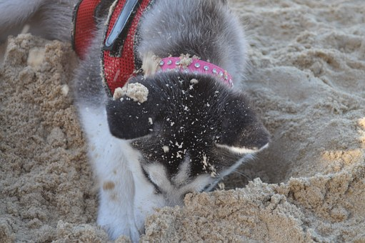
- Uncovering items
Spot’s senses of smell and hearing are much more sensitive than those of humans. He can hear the ultrasonic noises produced by some underground inhabitants and can detect odours through many layers of soil.
So Spot may be digging in reaction to stimuli from underground that you haven’t identified. If he paws, sniffs or listens intently prior to digging then you might need to consider the possibility of small mammals such as mice, or insects such as termites (in which case you should give Spot an extra special treat for alerting you and saving your house from demolition!).
In this case Spot could benefit from the opportunity to use his skills more appropriately by learning how to track or retrieve. Speak to the Instructor listed on the front of this handout for information on teaching Spot these skills.
You could also try giving Spot some exciting alternatives, such as noisy, squeaky toys to play with. Alternatively, perhaps leaving a radio turned on in the area most affected (ensure it is battery operated and out of Spot’s reach) may help to combat the underground noise.

- Temperature regulation
If Spot digs only on cold days and spends a lot of time nestled in the hole he has dug, then he needs more protection from the cold weather. Many of today's dog breeds do not have the thicker fur common to their ancestors and are therefore not adequately insulated against the cold. Provision of adequate shelter, clean bedding and possibly a heat source such as a hot water bottle or a heating pad (neither of these are for chewers) will help to reduce the need to dig to maintain warmth.
If Spot is outside because he is not housetrained, please refer to our handouts on Toilet training. These will help you to housetrain Spot so he can stay inside on cold days and nights and won't need to dig to stay warm!
If, on the other hand, Spot lays stretched out on newly exposed soil in hot weather, then you need to provide relief from the heat. A small wading pool, access to shaded areas and the odd gravy ice block to lick on (just freeze some gravy in an ice cream container or ice cube tray) will help him keep his cool. You can also stuff his Kong or similar chew toy with mushy food and place it in the freezer overnight. Next day he will have a wonderful Kongsicle to suck on!
- Anxiety or escape
If Spot is digging to escape, then identifying the reason for the desire to get out of your yard can provide the key to managing the behaviour. So if Spot is not desexed, and he digs under the fence to visit a bitch in season down the road, then desexing may help with this problem.
Have a look around the area where Spot spends most of his time when alone – you need to be honest with yourself here! Is there plenty of opportunity for him to occupy himself, or is your yard pretty boring? Does he have items to amuse himself with, different areas to play in and the opportunity to use his various senses? Or is the area devoid of activity related options?
It doesn't matter how big Spot’s yard is – if it is boring he may be digging to escape to a better life! You can make his area more exciting by adding toys and activities, sights, sounds and smells. The more fun he has in his area, the less inclined he will be to want to escape!
Frantic digging can sometimes occur in the presence of thunderstorms and fireworks, or when Spot is separated from his favourite people. This behaviour can be the result of anxiety based disorders such as phobias.
An unusual cause for excessive digging occurs in some individuals with obsessive compulsive disorder. If you believe Spot’s digging is the result of a phobia or disorder then please contact your Instructor listed to discuss this further. These individuals may require medication and a consultation with a qualified Veterinary Behaviourist for appropriate behaviour modification techniques.
- Playing
If Spot is a young dog, he may simply be digging as part of his play behaviour. He may find the stimulation of roots, rocks etc that "play back" by rolling, clinking, etc. to be rewarding.
If Spot digs for the sheer pleasure of it he can be redirected to other activities that he finds enjoyable. We suggest you provide plenty of activities, chew toys, etc for Spot to keep himself amused. Remember to teach Spot how to play with his toys – he may not automatically know how to get the best result, especially if his toys are modern technical masterpieces!
- Territorial Marking
Spot may sometimes use his rear legs to scratch soil around an area he has just urinated or defaecated on. This behaviour may vary in intensity according to Spot’s age, gender and confidence in himself.
He may make these scratches to mark a particular spot with a scent and visual signal as a sign to other dogs that he is present, particularly if he is an un-desexed male. Some bitches will do this as well.
This behaviour does not normally cause a problem for most owners, as there is no actual hole dug. However if it is a challenge for you, desexing Spot may help, as he may be less inclined to be assertive about his presence.

Other ideas to help:
You probably prefer your lawns and gardens to remain pot hole free, so it is a great idea to provide Spot with his own digging pit. Perhaps an area close to his kennel, or screened off near the rear of the yard. Surround the pit with bricks or similar to confine Spot’s digging to a manageable area and fill it with freshly tilled soil.
To teach Spot to use the pit, have someone hold Spot a small distance away whilst you dig in some of his favourite bones, toys, treats, etc. In the early stages make sure you bury these items fairly close to the surface, so he succeeds quickly.
Release Spot and encourage him to dig in the pit by throwing treats into it and enthusiastically supporting his sniffing and pawing at the soil. He will soon discover the buried treasure and will be very excited – he gets to dig and discovers treasure as well!
As he begins to understand the concept, bury deeper, and place obstacles such as bricks on top of the buried items so he has to move them to find his treasure.
Freshly tilled soil is usually most attractive to ardent diggers so if you bury lots of high value items in this area and make it seem extremely interesting from the outset then Spot will learn that this area is a lot more fun to dig in than your best rose garden. Your aim is to make Spot want to dig here rather than anywhere else in your yard.

Why Punishment Is Rarely Effective?
Punishing Spot for digging is generally ineffective because it is almost impossible to catch him every time he begins to dig a hole. Reprimanding after he has dug is too late as he will associate the punishment with whatever he is doing when he is punished and he will already have been rewarded from the activity of digging!
Even if caught in the act, Spot may actually enjoy the attention he receives when he is punished. In his opinion, bad attention from you may be better than no attention from you! He may also realise that there are no repercussions if you are not present when he digs, so may reserve his digging activity for those times when you are absent.
Be patient – it takes time for Spot to learn what you want – and what you don't want!

Barking

So, you have a dog that barks? Barking dogs are high on the list of complaints received by local councils and are often the cause of major disputes between neighbours. Some people are more tolerant than others, however generally speaking a dog that barks a lot is a source of annoyance and frustration to everyone.
Does my dog bark just to annoy me?
No! Your dog (let's call him Spot) doesn't bark just to annoy you – even if it sometimes seems that way! Barking is a natural behaviour for dogs, with certain breeds of dogs and some individuals being more inclined to bark than others. Domestication and life in today's society have provided Spot with more reasons to bark than his wild wolf ancestors had.
In the wild, barking more than necessary would have alerted other animals to the pack's location and driven prey away, so was mostly kept to a minimum. Today however, Spot’s meals are usually provided for him so he has fewer concerns about his survival and is therefore willing to bark more.
Humans have also created breeds designed to bark more, alerting them to the presence of intruders, or to the presence of pests such as rodents, so we are actually responsible for the barking problem!
So, why does Spot bark?
Spot usually barks as a response to something that has excited him or caused him to become anxious. He also learns that barking can be rewarding in a variety of ways.
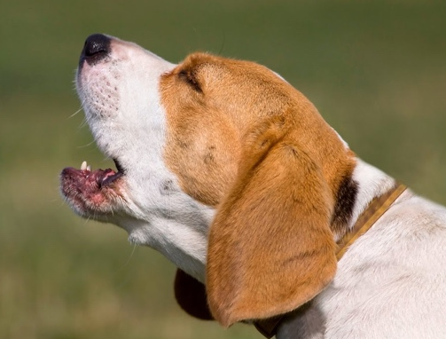
Understanding the reasons why Spot barks, and why he finds it rewarding, will help in finding solutions. Some of the more common reasons for barking are:
- Territorial/Protection
- Boredom
- Attention Seeking
- Anxiety
- Playtime Enthusiasm
- Health Problems
- Hunger/Thirst/Shelter

In most cases Spot is not a "problem" dog. There is usually a problem with his environment or relationships. Let's have a look at each of the above reasons for barking and explore ideas for alleviating the problem.

Territorial/Protection
Does Spot bark when other people or animals come close to the boundaries of your property? Does he bark when visitors arrive? If the answer to these questions is "Yes", then it could be that Spot is barking to proclaim and protect what he sees as his.
Spot is by nature a social animal and is happiest when living with a social group which he sees as being "his" group. This social group is generally made up of whoever normally inhabits your house and may include human members, another dog and a cat or two, etc. Spot will also see the family home and yard or property as being part of the group's territory and will therefore feel he has a right to defend it.
Spot’s survival instincts tell him that he must protect the members of his group, and his territory, from invasion by others. So when people or animals outside his social group come close to or invade his territory, or come close to the other members of his group, he may react by barking. He is barking to warn them that they are trespassing on his territory, or possibly threatening his group.
Spot has discovered that if he barks, most dogs and other animals will quickly depart from his territory. Humans too will think twice about entering the house or yard and may react by retreating. So Spot is rewarded for the barking behaviour because the intruders retreat and are no longer threatening.

Management ideas for Territorial/Protection:
- Spot needs to learn that he is not in charge of his social group. Good training helps Spot see you as his leader. Once Spot realises he is not responsible for the welfare of his group he may bark less when visitors arrive. It should also be easier for you to request that he stop barking, as he will see you as his leader.
- Making visitors a rewarding experience for Spot will also help. To do this you need plenty of treats and toys on hand when visitors arrive. Have the visitors offer Spot a treat or toy. If he stops barking to sniff the treat, praise him and allow him to take the treats. This way he is being rewarded for being quiet and will learn that visitors are not intruders – they are actually great fun to have around!
- If Spot is barking at people or dogs walking past your yard, you could consider restricting Spot’s access to these areas to times when you are present and can "take charge" and request that he stop barking.
- You could build a more solid barrier, so Spot cannot see the "intruders".
- You could provide something more exciting for Spot to concentrate on when people walk past, and reward Spot for ignoring them.

Boredom
Spot can suffer from boredom if his environment is lacking in stimulation. Even a big yard can be just a large prison for him; after all, he has all day, every day, to get to know every inch of it.
If Spot is bored, in effect an "urban prisoner", he can end up quite stressed. He can't change his job, alter his environment, read a book, listen to music, or go for a long walk, as we humans can, to relieve the effect of stress. Boredom can lead to barking, which Spot uses to express his dissatisfaction and to relieve some of his pent-up energy.

Management ideas for Boredom
Boredom means that Spot is not receiving enough mental or physical stimulation. To address this need you should provide:
- Some daily training sessions (trick training, agility, obedience, or simply good manners) will exercise Spot’s mind and utilise his physical skills.
- Exercise in the form of walks (on loose lead and allowed to sniff) and regular play sessions. Some short, intense physical games, such as Frisbee or ball will help expend that physical energy. If you spend most of your day away from him, it is a good idea to provide this exercise before you leave, so he is feeling physically satisfied and content to doze or amuse himself.
- Time for cuddles and massage when you are home. Spot is a physical creature and enjoys being made a fuss of.
- Socialisation with other friendly dogs and regular access to his friends.
- A morning feed, or divide his daily ration into two, and feed morning and evening. This way he has something to feel contented about when you leave in the morning.
- Large raw (never cooked) bones to chew or chew-toys such as a "Kong" to keep him occupied.
- Access to part of the house while you are away. Install a "Doggy Door" and give your house a burglar deterrent from the inside as well.
- Regular outings. If you are lucky enough to be able to have Spot at work with you, take him! If you teach him how to be well-mannered in public he will be more likely to be welcomed at the homes of friends and relatives as well.

- Attention Seeking:
As we said earlier, Spot is generally a social animal. He enjoys company and is not overly content if left alone a lot. Barking tends to gain attention and Spot soon learns that if he barks long enough or hard enough someone will interact with him in some way. Something as simple as sticking your head out the door and telling him to be quiet is seen by Spot as being successful in having gained your attention.
In Spot’s opinion any attention is better than no attention – especially when you join in by barking back at him! Even punishment is seen by Spot as being worthwhile – he has gained your attention and you have interacted with him.

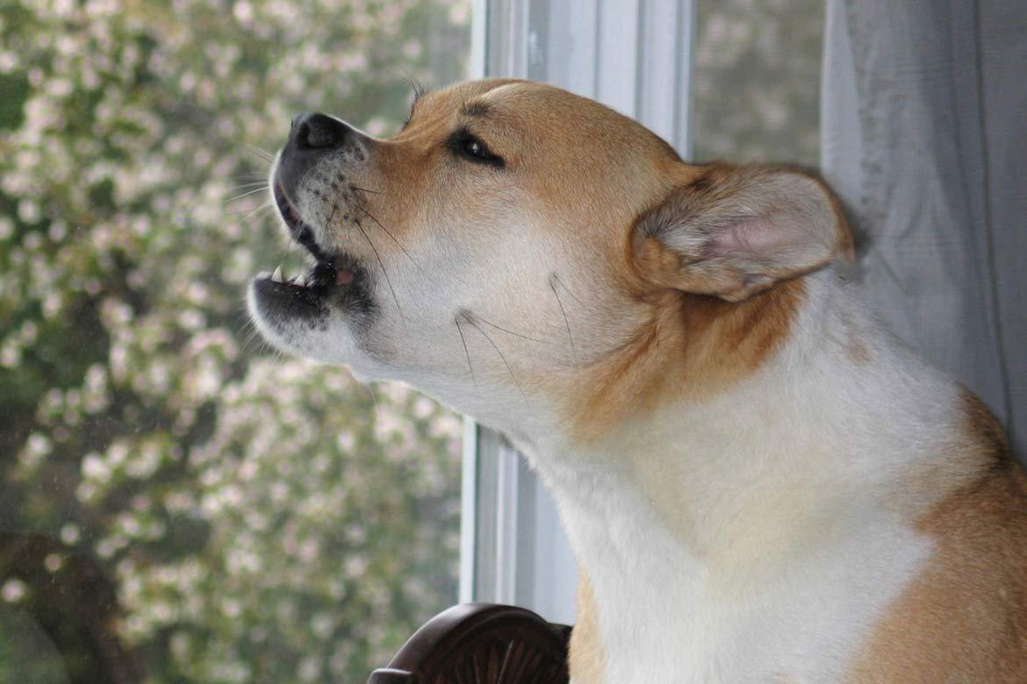
Management ideas for Attention Seeking
- The main issue here is to avoid paying attention to Spot when he barks and pay more attention to him when he is quiet. Try to anticipate those occasions when he normally barks to gain your attention and give him attention before he begins.
- If you miss this opportunity and he has already begun to bark, then you should take no notice of him whilst he is barking – do not speak to him, pat him, or even look in his direction! He will see any reaction from you as being a result of his barking, so you need to show no response. As soon as he stops barking respond with praise and attention. For example, if you normally open the back door when Spot stands there barking, either open it before he has a chance to begin barking, or after he stops.
- If Spot is an outside dog and usually begins to bark in his pen before you let him out in the morning, you either need to go out before he begins to bark (you can gradually get back to your normal timetable once he learns that not barking gets a better result), or resist the urge to yell at him to "Be Quiet!" and wait until he stops barking before going out
- Ensure Spot has daily interaction with you to fulfil his social needs. If he has his mental, physical and emotional needs tended to, he will be less stressed and less inclined to want your constant attention. The section above on management ideas for "Boredom" can help here.

- Anxiety
Do you find that Spot follows you everywhere when you are at home, possibly even trying to go to the bathroom with you? Does he complain when shut away from you? Allowing Spot to become very dependent on you can lead to anxiety when you are away. This in turn can cause Spot to bark because he is anxious about your absence. Even a simple change in your daily routine or household circumstances can become a major issue for him.
This can be a most frustrating problem and it is best you ask your Instructor for a referral to a qualified Veterinary Animal Behaviourist if you feel Spot has this problem.

Management ideas to prevent anxiety
To prevent Spot from developing this problem, try the following:
- When you are away, allow Spot access to the house and in particular, a bed or den in a safe familiar place with an old jumper that has your scent on it.
- Prepare a meal for Spot and give this to him as you leave along with toys and a bone to help distract him.
- Try leaving a radio or TV on softly in the background to give the impression of company.
- Gradually get Spot used to being separated from you for an increasing length of time while you are at home. Put his bed in a convenient area where he can see you moving from room to room and install a cheap, simple toddler barrier in the doorway to stop him from following you everywhere.
- Keep arrivals and departures very matter of fact and low key - don't make too much of a fuss at either time.
- Reward Spot when he is quiet and relaxed.

Playtime Enthusiasm:
You may find that Spot tends to bark when he is playing with you. He may simply be excited about the play session, or frustrated that he cannot have unlimited access to the toys that you may possess.

Management ideas for Playtime Enthusiasm
The key here is to reward Spot for calm, quiet behaviour and show him that you will not play whilst he is barking.
- If he usually barks to get you to play a game, either begin play unexpectedly before he barks or wait until he draws breath between barks and begin play then. If he will not stop, put the toy away and try again later.
- Reward him with a treat when he brings toys back to you and begin playing again before he barks.
- Keep play sessions low key to prevent escalation of excitement. High intensity play sessions should only last for a short while between calmer activities.
- Request a good manners behaviour such as "sit" or "drop" before and during play sessions to refocus him.
- Teach him to settle between throws or tugs.

- Health Problems
Does Spot suffer from fleas, a skin allergy, ear irritation/infection, arthritic aches or pains? All these things can contribute to making him irritable and more likely to be annoyed at disturbances.

Management ideas for Health Problems
Make sure Spot is in good health. If any of the symptoms mentioned above are present, or if you feel there is anything unusual about his state of health, make sure he has a Veterinary check-up immediately. These conditions and other health problems can contribute to behaviour problems.
- Hunger/Thirst/Shelter
Check Spot’s living conditions thoroughly. Is he well-fed? Does he have access to plenty of clean, cool water? Is he sheltered from climatic conditions – both hot and cold? He may be trying to tell you that he is uncomfortable. It is your responsibility as his primary carer to make sure he has all the necessities for a comfortable life.
Why shouldn't I physically punish Spot for barking?
Some people promote various punishments for barking, ranging from yelling at Spot, to hitting him with rolled up newspapers, or using electronic or chemical collars.
In most cases the punishment does not deter Spot, as the reason for his barking is not being addressed. He may stop barking in the short term, but will generally begin again before too long.
Most punishments are also cruel and likely to make Spot anxious and stressed about why he is being punished and can lead to Spot displaying aggressive behaviour toward people – hardly conducive to a good relationship between you and him! We believe it is far better to work out why Spot is barking and remedy the situation so everyone benefits.
Are there other reasons for Spot’s barking?
Yes! We have listed only the most common reasons, but there are many other reasons why Spot may bark.
He may bark at children coming home from school, shouting and banging the fence. A dog barking further up the road or in the next street may set him off. A neighbour calling out, or starting their car or lawn mower, or a cat teasing from the safety of a neighbouring tree or fence could be the catalyst. If in real desperation, there are always birds, bees and jumbo jets to bark at!
It is up to you to use your initiative to think about the problem and ways to solve it. You could ask for children's co-operation not to tease Spot. You could allow Spot continual access to inside the house (via a doggy door) so he is less distracted by what is going on outside.
Another idea that sometimes helps is to teach Spot to bark on command. If you teach this in a controlled manner you will also be able to teach "Shush". Speak with your Instructor for ideas to teach this.
If Spot’s barking is a problem for your neighbours, it is best to let your neighbours know that you are aware of the issue and that you are working to solve it. Perhaps you could enlist their help and co-operation by asking them to say hello to your dog through the day and give him a treat (when he is being quiet). Remember to introduce your dog to the neighbours before you do this, so he is happy with them throwing things over the fence! Barking can be a frustrating behaviour, however if you are observant you can usually discover what makes Spot bark. Applying the appropriate management ideas from this handout will generally help, however for best results do this under the supervision of your Instructor.

Toxic Plants and Food
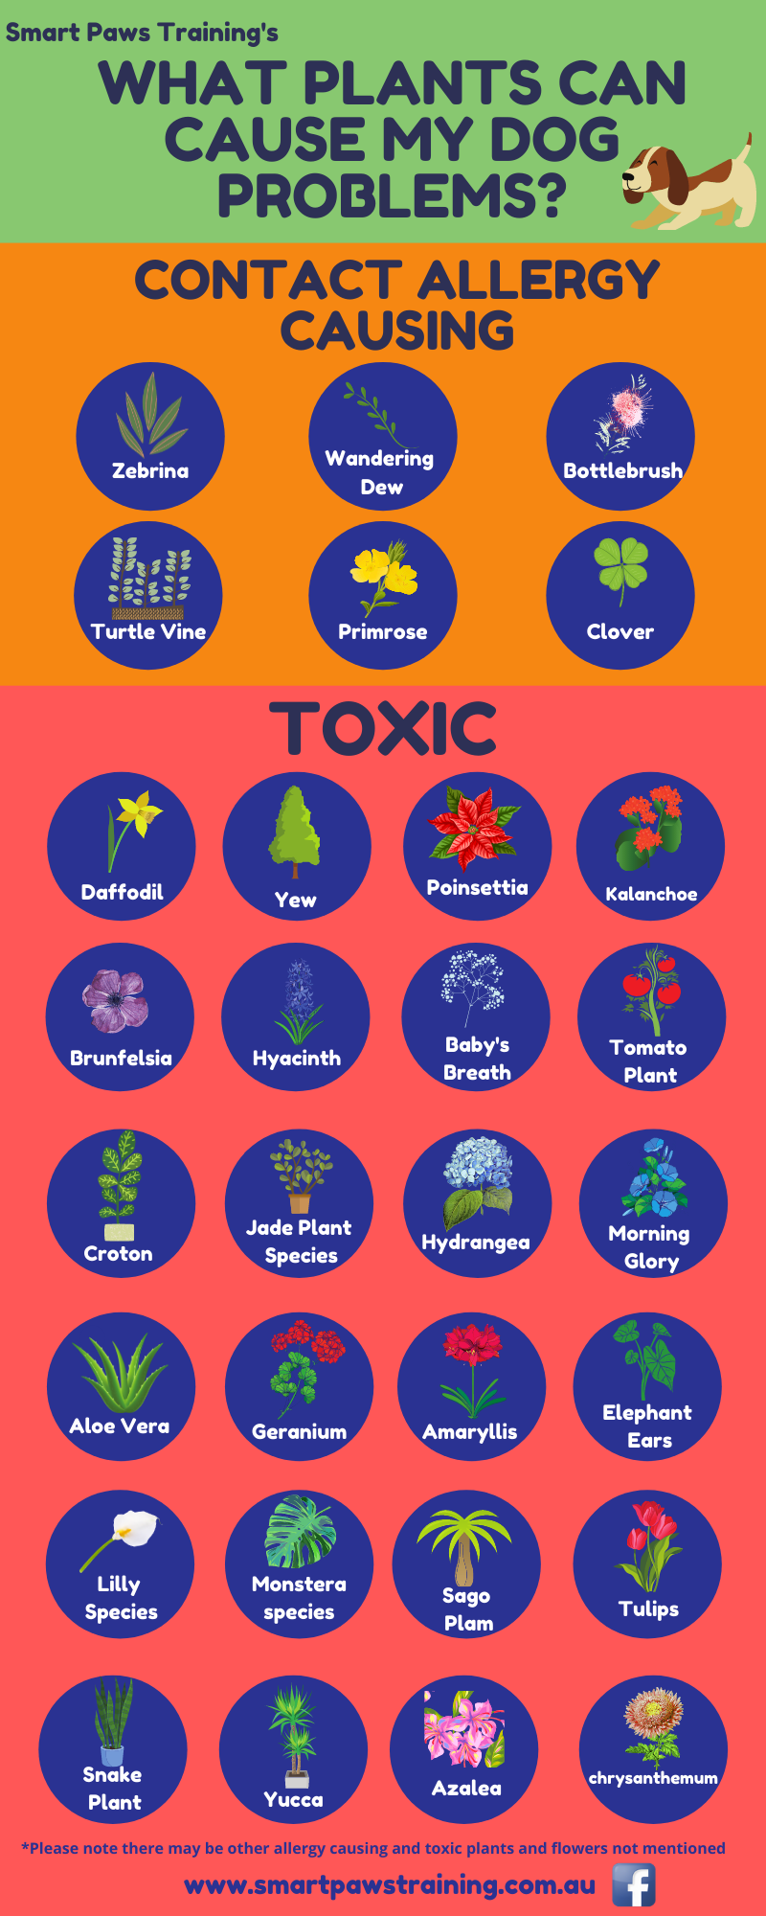
There are many plants and food items that can be toxic to your pets.
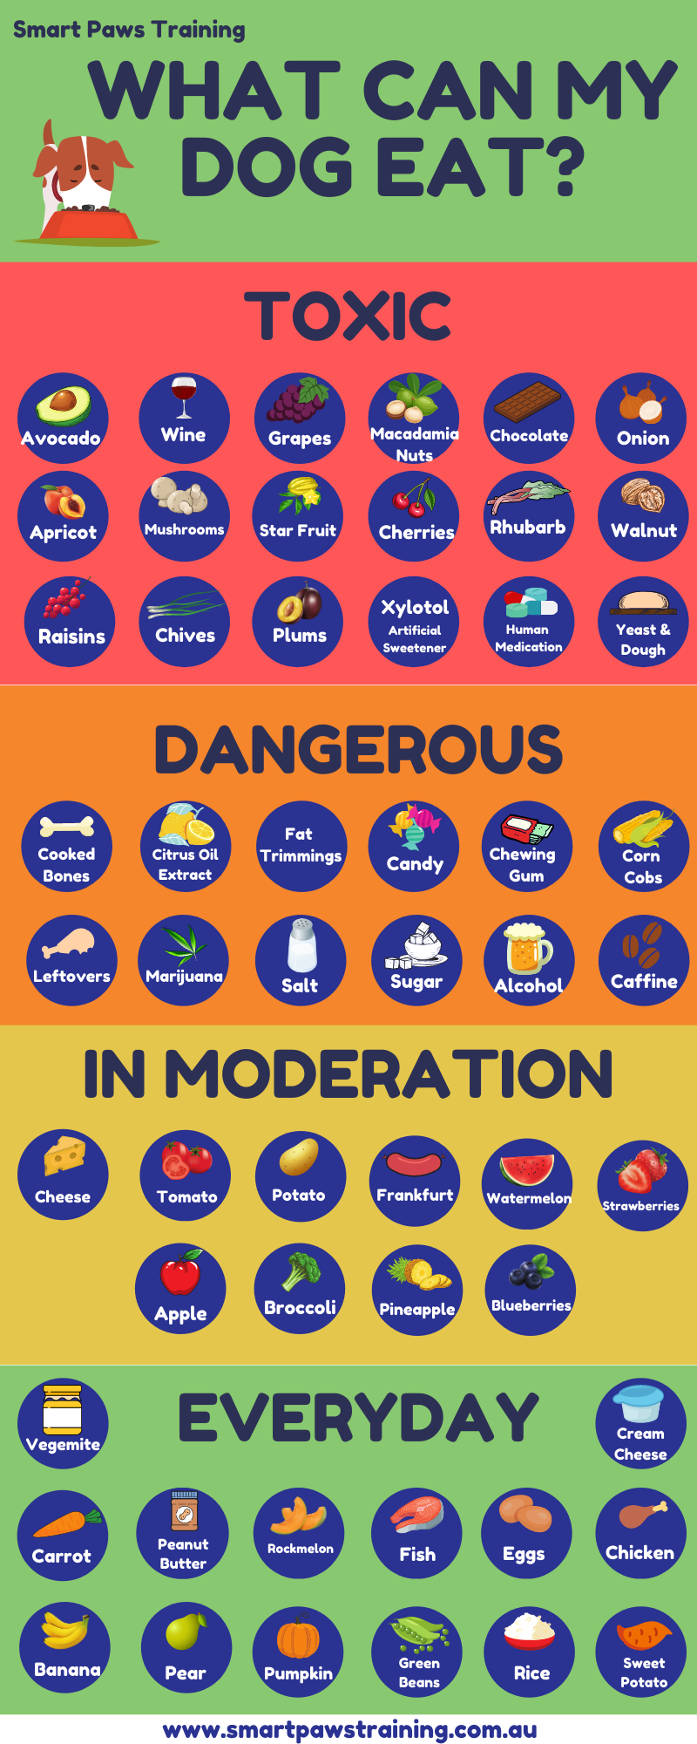

Nail clipping
Regular nail trims are important to blunt the sharp tips to minimise accidental scratches
- Be cautious to avoid blood vessels in the pink base
- Only use trimmers designed for dogs
- Nail trims should be introduced gradually, Initially a few nails should be trimmed each week until they are familiar. Nail trims should happen every 6-8 weeks.
- Don’t forget the dew claws which are the extra toes on the from and sometimes back feet on some dogs.
If you do accidently catch the kwik and the toe starts to bleed, gently scape the toe in a cake of soap to make a casing at the end of the toe to stop the bleeding.

